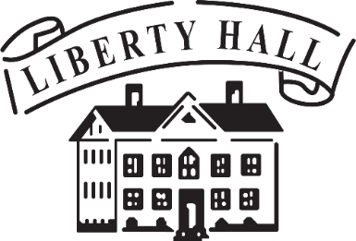 **Bourbon & Browns 2025**

**Sponsorship Opportunities**

**Saturday April 26th**

**Liberty Hall Sponsor  
$10,000+**

* Recognized as the lead sponsor of the event
* Listing in electronic and print communications; web site, social media,

e-marketing, event invitation, event site signage, and program

* Presenting sponsor table for 10
* Attendance for 10 to VIP Bourbon pre-event with Honorary Chair, Marcey Broderson

**Orlando Brown Sponsor   
$5,000 - $9,999**

* Listing in electronic and print communications; web site, social media,

e-marketing, event invitation, event site signage, and program

* Sponsor table for 8
* Attendance for 8 to VIP Bourbon pre-event with Honorary Chairs, Marcey Broderson

**Keystone Sponsor  
$2,500 - $4,999**

* Listing in electronic and print communications; web site, social media,

e-marketing, event invitation, event site signage, and program

* Sponsor table for 6
* Attendance for 6 to VIP Bourbon pre-event with Honorary Chairs, Marcey Broderson

**Palladian Sponsor   
$1,000 - $2,499**

* Listing included on event invitation, event site signage & program
* 4 tickets to the event
* Attendance for 4 to VIP Bourbon

pre-event with Honorary Chairs, Marcey Broderson

**Capital Sponsor   
$500 - $999**

* Listing on site signage & in program
* 2 tickets to the event
* Attendance for 2 to VIP Bourbon pre-event with Honorary Chair, Marcey Broderson

**Cornerstone Sponsor   
$250 - $499**

* Listing on event program
* 1 ticket to the event

For Palladian Sponsors and above, the deadline for inclusion in the invitation is **February 15th**

For questions, call (502) 227-2560 or email info@libertyhall.org