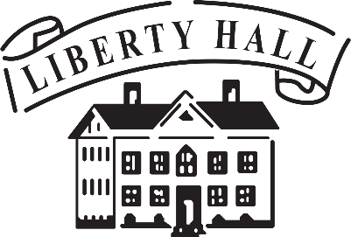

**Bourbon & Browns 2025**

**Sponsorship Reply Form**

**Saturday, April 26th, 2025**

**Due by February 15th to be listed on the invitation.**

***(Please note: Only Palladian Sponsors and above will be listed on the invitation)***

Sponsor Name: ______________________________Contact: ___________________________________

Mailing Address: ____________________________ City: ____________ State: ____ Zip: _____________

Phone: ___________________________ Email: ______________________________________________

**Choose a Sponsor Level**

* Liberty Hall Sponsor $10,000+  Palladian Sponsor $1,000 - $2,499
* Orlando Brown Sponsor $5,000 - $9,999  Capital Sponsor $500 - $999
* Keystone Sponsor $2,500 - $4,999  Cornerstone Sponsor $250 - $499

**AMOUNT**: ______________________

**Indicate Your Method of Payment**

* Check (enclosed) **Payable to LHHS – Memo Line: B&B Sponsorship**
* Credit Card (complete form below)

***If you prefer to pay in installments, please call (502)227-2560 to make arrangements.***

**Card Information**

Name on Card: ______________________________________ Card Type: ____________________

Card #: ______________________________________ Exp. Date: ________________ Code: ______

Signature: _____________________________________ Date: ______________________________

**Please send this form to:**

**LHHS, 202 Wilkinson St., Frankfort, KY 40601**

**or Email info@libertyhall.org with subject line - *B&B Sponsor Form***